Project Design Phase-II
Data Flow Diagram & User Stories

Date | 2 November 2025
Team ID | NM2025TMID02717
Project Name | Optimizing User, Group, and Role  Management with Access Control and Workflows
Maximum Marks | 4 Marks

Certainly, Sirisha! Here's a tailored description of a Data Flow Diagram (DFD) for your project on Role-Based Access Control and Workflow Management:

Data Flow Diagram (DFD) - Project Overview
The Data Flow Diagram for this project visually representshow data moves through the system, emphasizing user roles, task management, and access control. It illustrates the flow of information between users (e.g., Project Manager and Team Members), the processes they initiate, and how data is
stored or modified within the application.

Key Elements of the DFD:

● External Entities:
o Project Manager and Team Members serve as external actors who interact with the system by creating tasks, assigning roles, and updating statuses.
● Processes:
o User Registration & Role Assignment: Assigns roles upon registration and updates access rights.
o Task Management: Allows creation, assignment, and status updates of tasks.
o Access Verification: Validates user actions based on assigned roles and permissions.
o Progress Reporting: Generates performance reports and task summaries.
● Data Stores:
o User Database: Stores user credentials, roles, and permissions.

o Task Repository: Holds all task-related information, including assignments and updates.
o Audit Logs: Tracks changes in roles, permissions, and task statuses.
● Data Flows:
o Data flows between users and processes, showing how a request (e.g., login, task update) travels through access validation before being stored or reflected in reports.

This DFD provides a clear visual summary of your system’s logic and data movement. If you’d like, I can help sketch it out or convert it into a presentation slide for easier sharing.
Example:(Simplified)

Example: Data Flow Diagram & User Stories

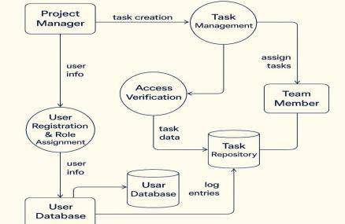

User Stories for Role-Based Access Control System

User Type

Administrator

Administrator

Project Manager

Team Member

Project Manager

Project
Manager/Admin

Administrator

Functional
Requirement (Epic)
User & Role Management

Access Control

Task Assignment

Task Management

Status Notifications

Reporting & Analytics

Role Update & Audit Log

User Story Number

USN-1

USN-2

USN-3

USN-4

USN-5

USN-6

USN-7

User Story / Task Acceptance Criteria

As an admin, I can define and assign roles (e.g., Project Manager, Team Member).  As an admin, I can configure access levels based on user roles.  As a PM, I can create and assign tasks to users based on their roles.  As a team member, I can view, update, and mark tasks as completed. | Roles are assigned during user  onboarding and stored in the system.  Users see only content and features relevant to their role.  Tasks are assigned and visible only to relevant users.  Task status can be modified and tracked by the PM.
As a PM, I receive notifications when a task is Notification is triggered on task status

updated.  As a user,I can generate reports on project progress and user activity.  As an admin, I can modify user roles and view change history. | change.  Reports display task metrics, user  performance, and project timelines.  Updated roles are reflected  immediately with change logs recorded.

Priority

High

High

High

Medium

Medium

Medium

Low

Release

Sprint- 1
Sprint- 1
Sprint- 1
Sprint- 2
Sprint- 2
Sprint- 2
Sprint- 3

